CS 255 System Design Document Template

This template lays out all the different sections that you need to complete for Project Two. Each section has guidance to prompt your thinking. You will need to continually reference the interview transcript as you work to make sure that you are addressing your client’s needs. There is no required length for the final document. Instead the goal is to complete each section based on what your client’s needs are. Remove this note when you are finished, and replace all bracketed text with the relevant information.

UML Diagrams

UML Use Case Diagram
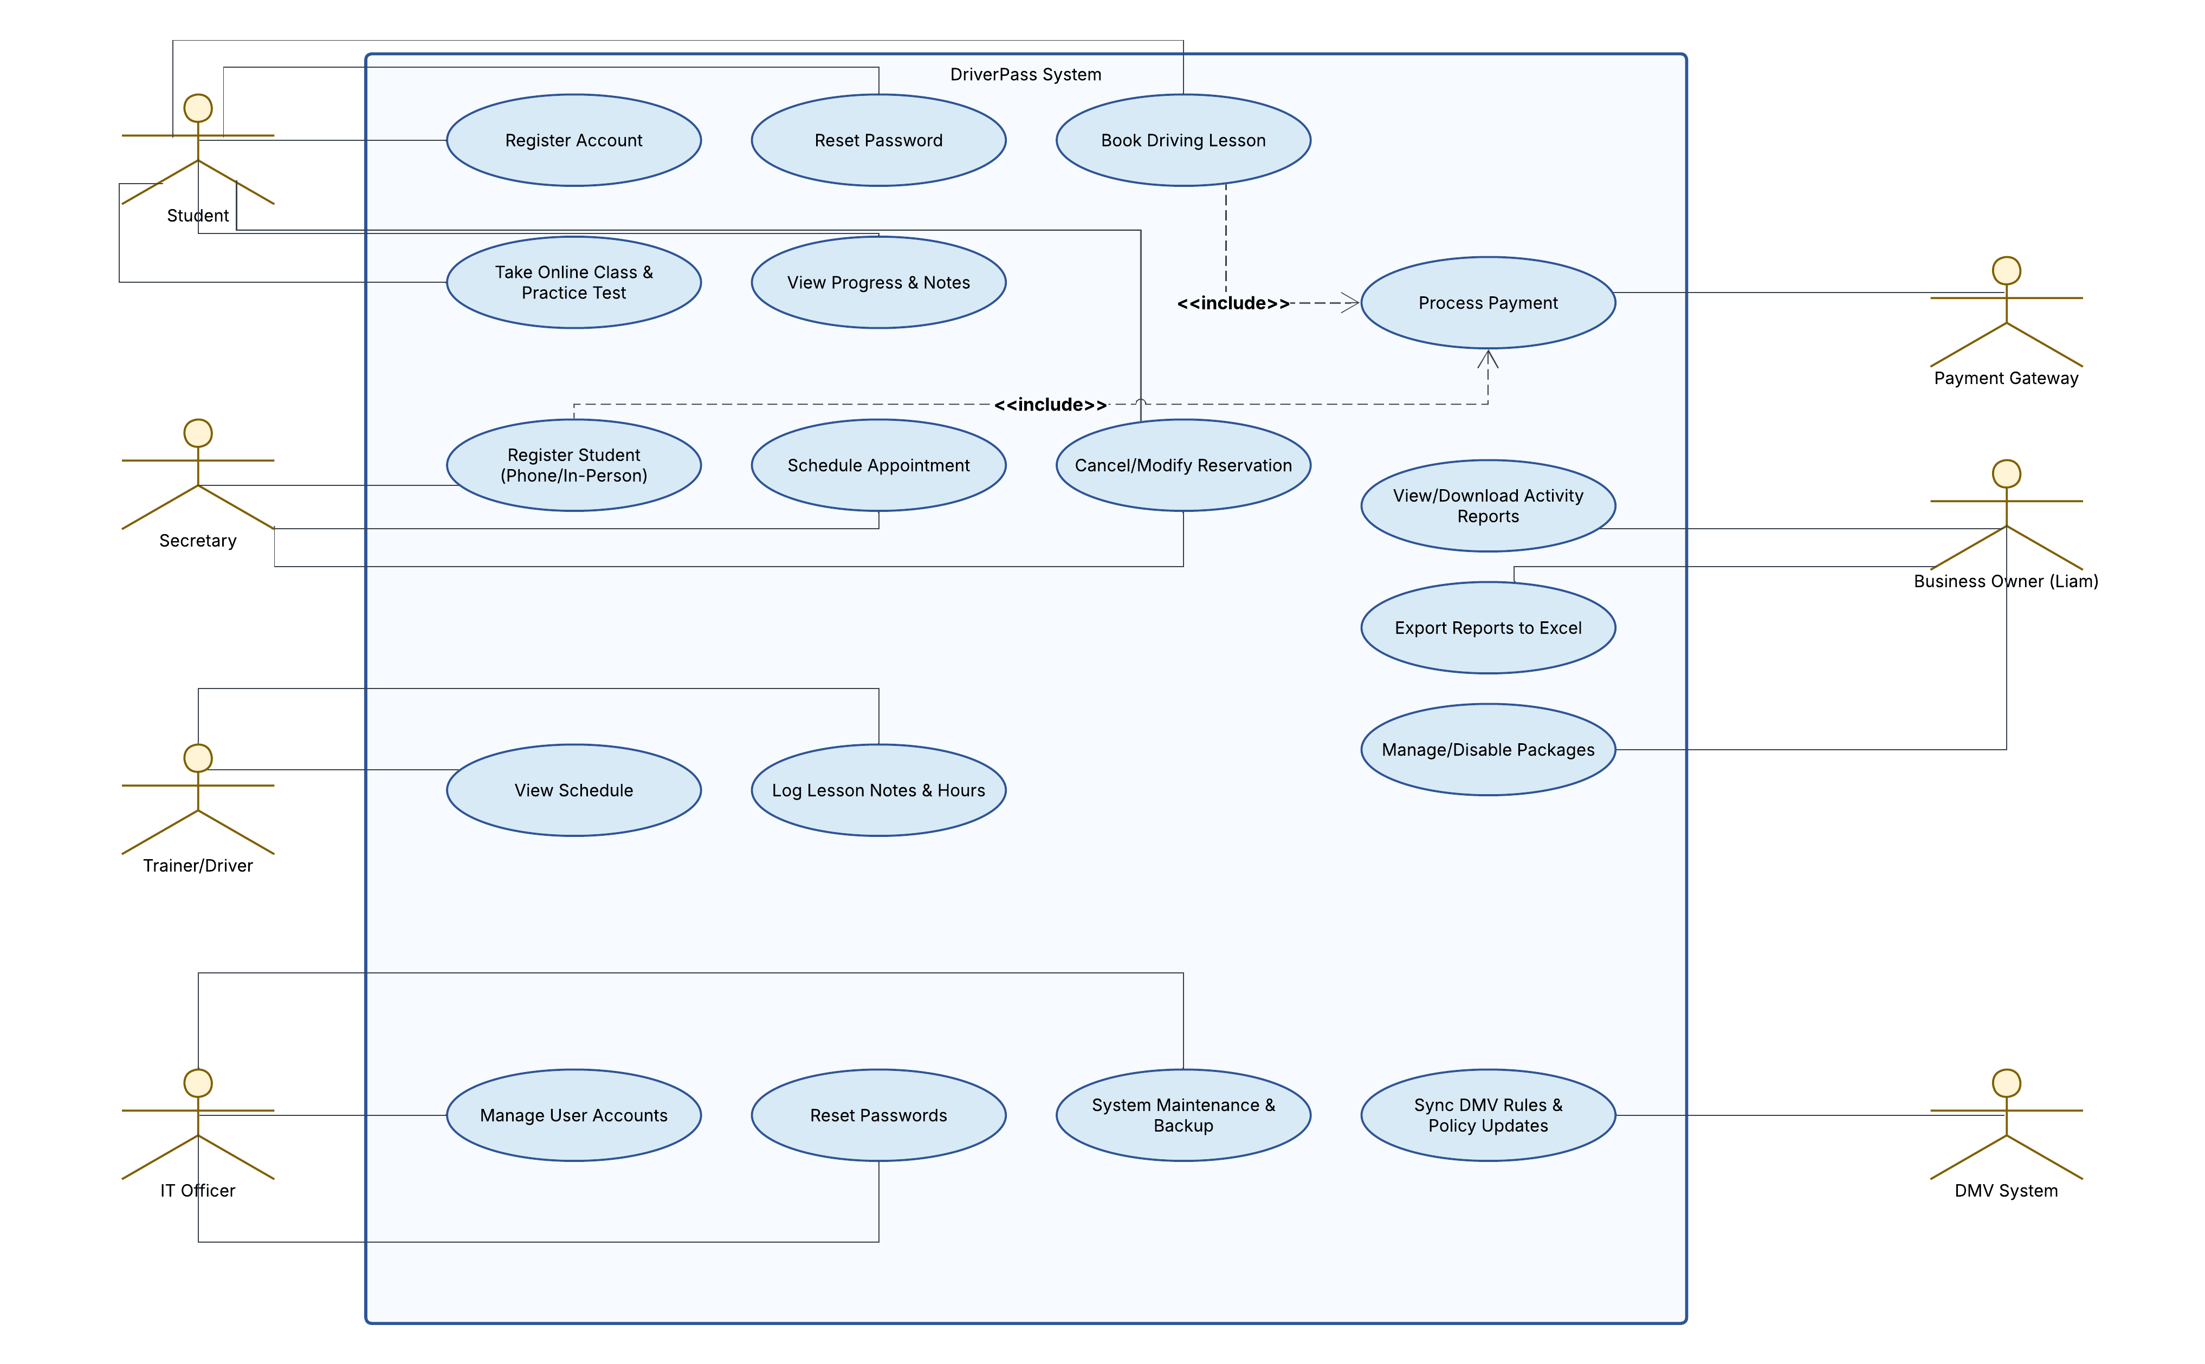

UML Activity Diagrams
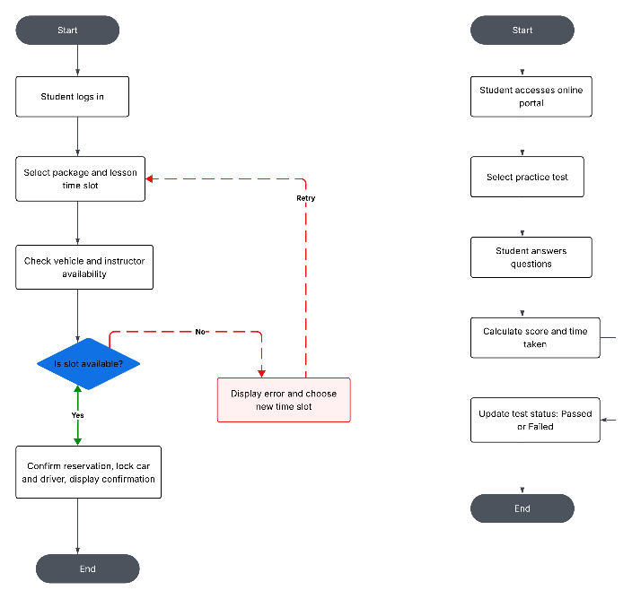

UML Sequence Diagram
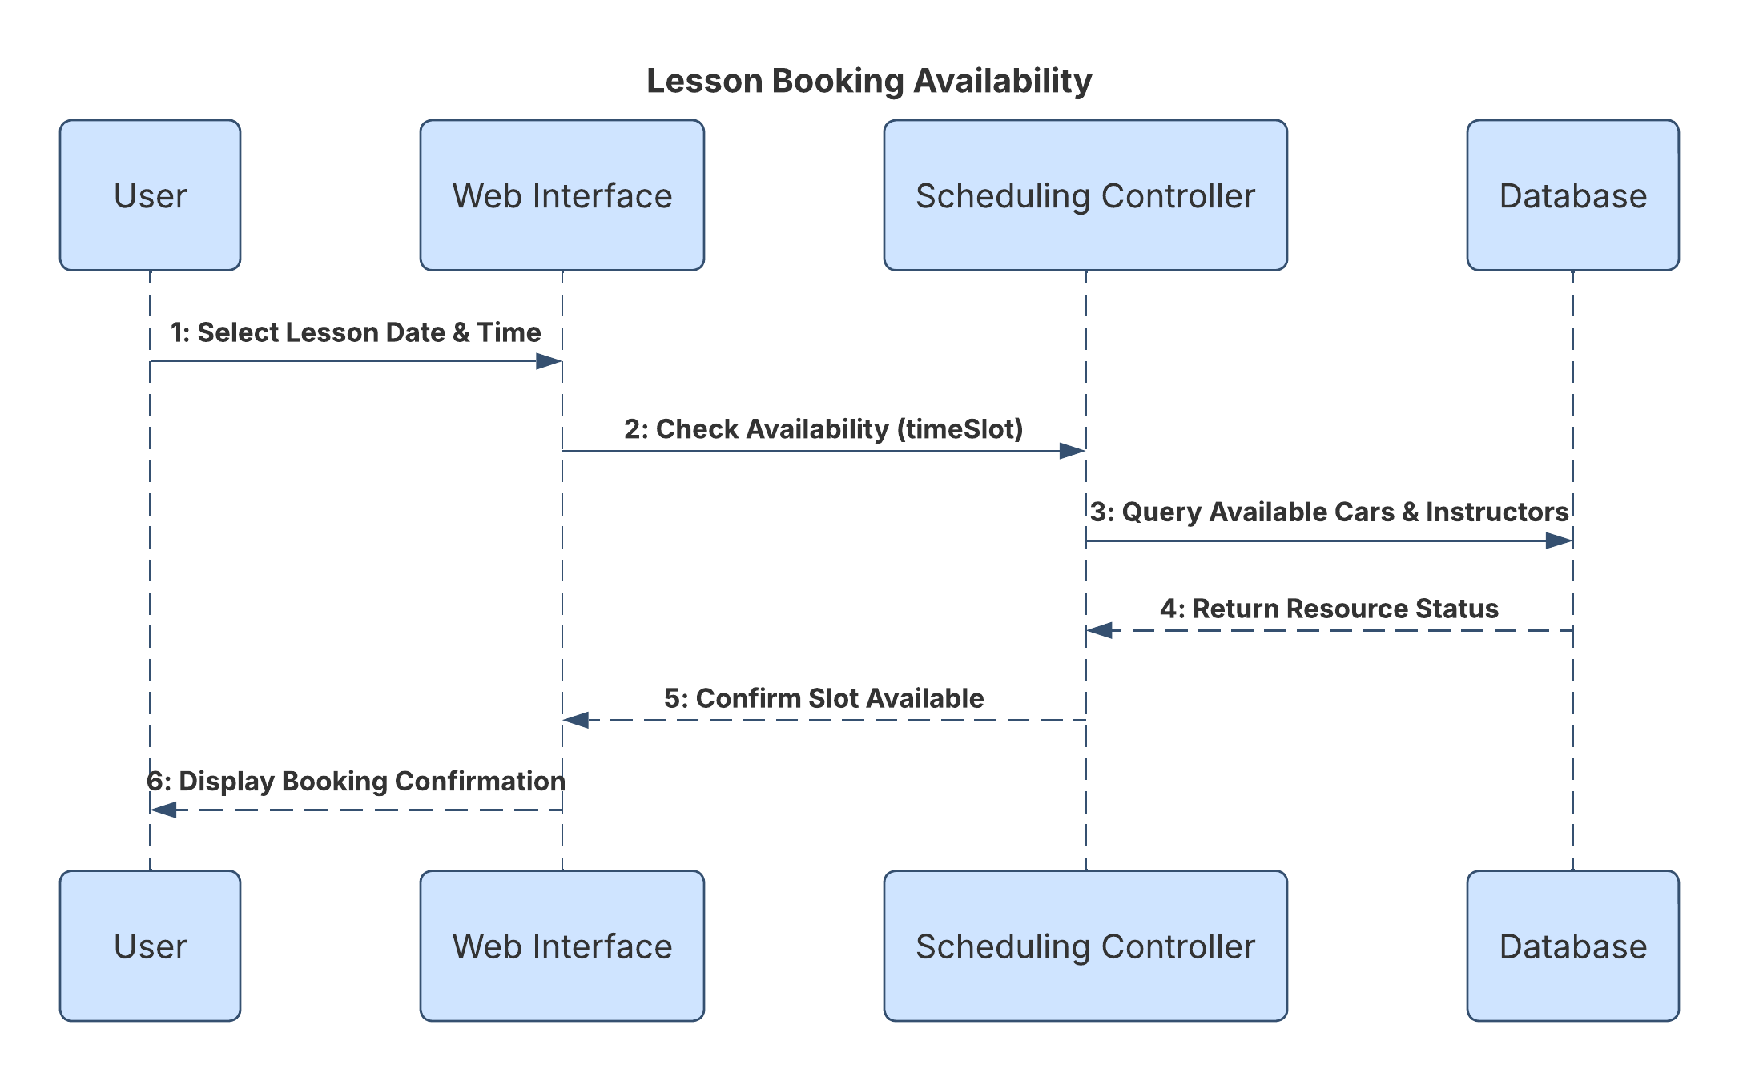

UML Class Diagram
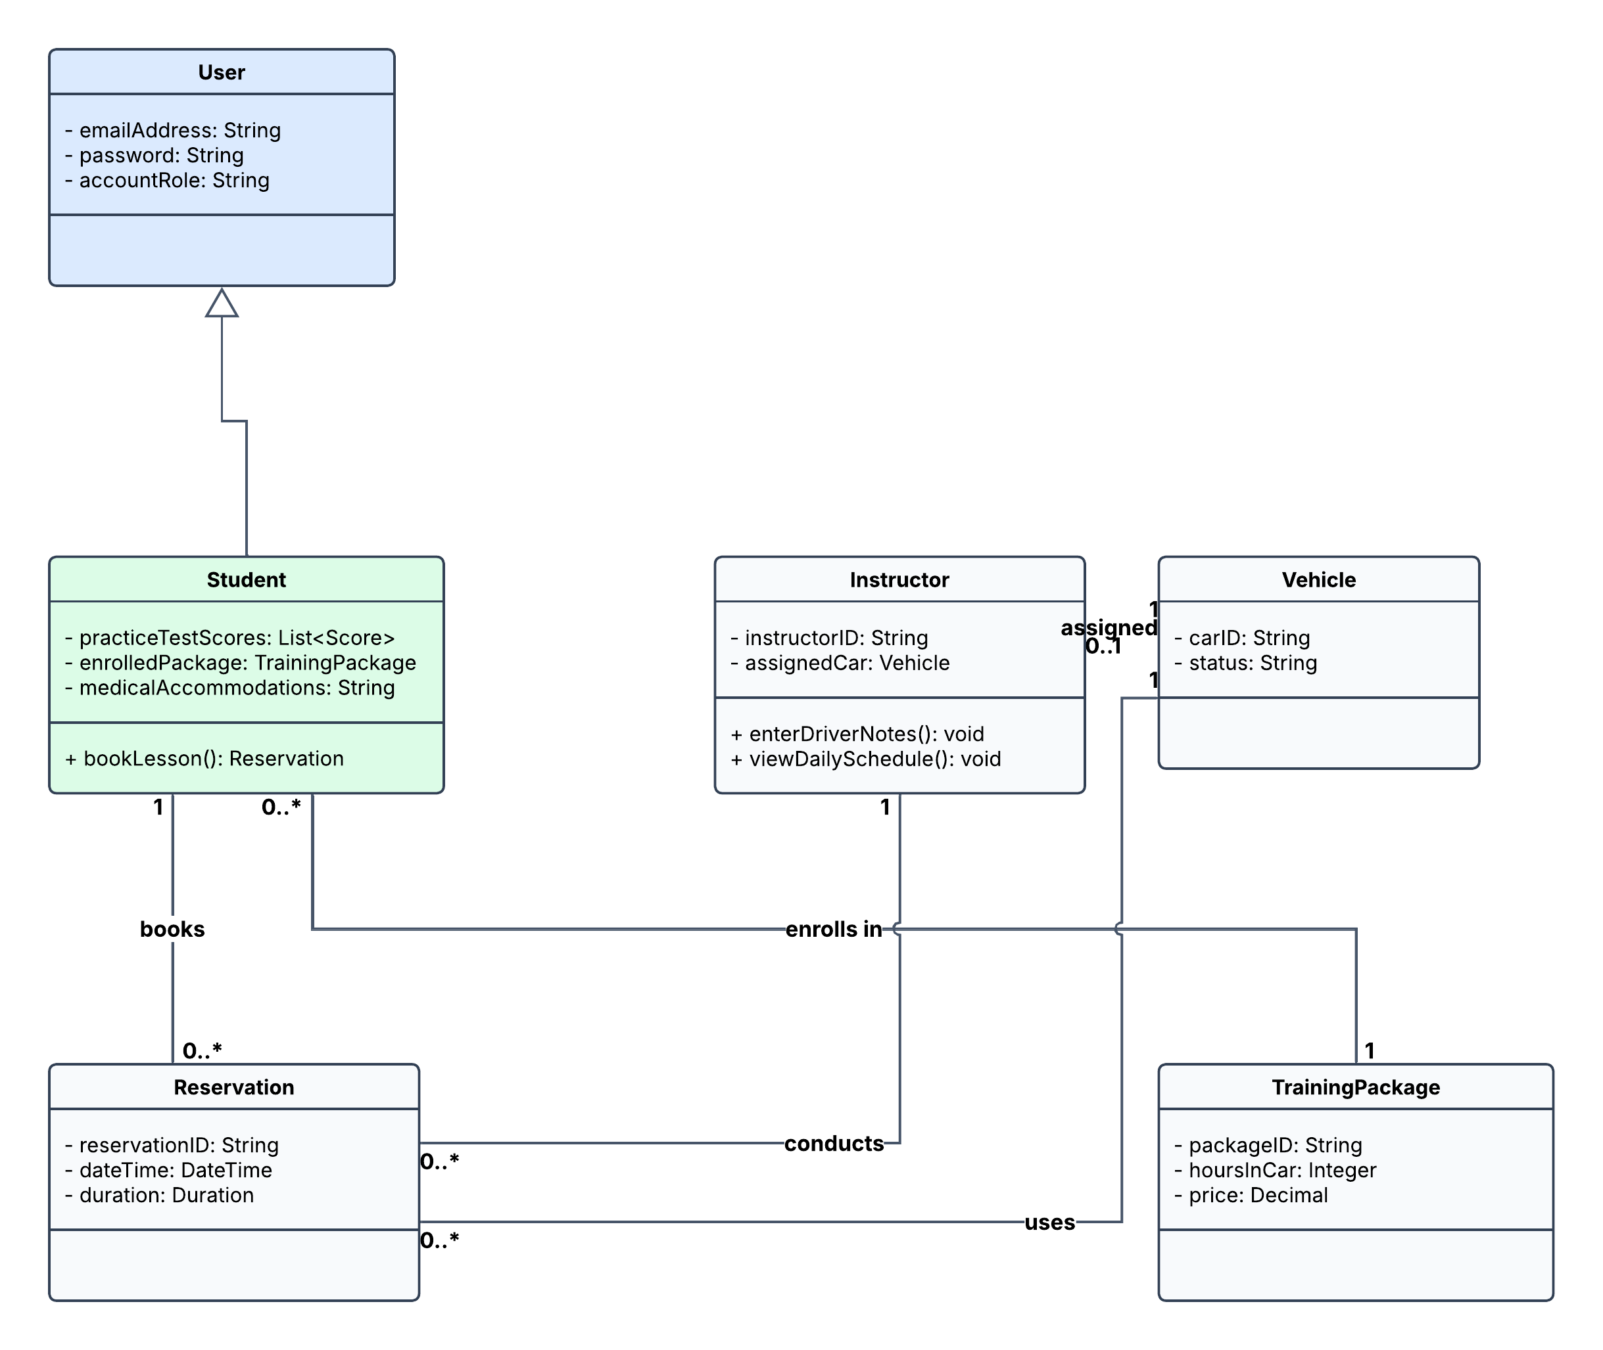

Technical Requirements
Cloud hosting on AWS or Azure will run the system seamlessly, sparing Ian (your IT officer) from having to worry about messy local server maintenance, physical hardware upkeep, or manual backup routines.

For day-to-day access, students and instructors can log in easily using any standard, modern web browser (like Google Chrome, Safari, or Edge) across Windows, Mac, or mobile devices. Behind the scenes, a secure relational database will safely store all encrypted student profiles, lesson scheduling data, question banks, and instructor notes. Plus, we’ve included a smooth reporting export tool so Liam can effortlessly download operational records into Microsoft Excel whenever he wants to work on them from home.

